Project Design Phase-II
Technology Stack (Architecture & Stack)

Date | 26 February 2026
Team ID | LTVIP2026TMIDS41542
Project Name | ShopSmart:Your Digital Grocery Store Experience
Maximum Marks | 4 Marks

Technical Architecture:
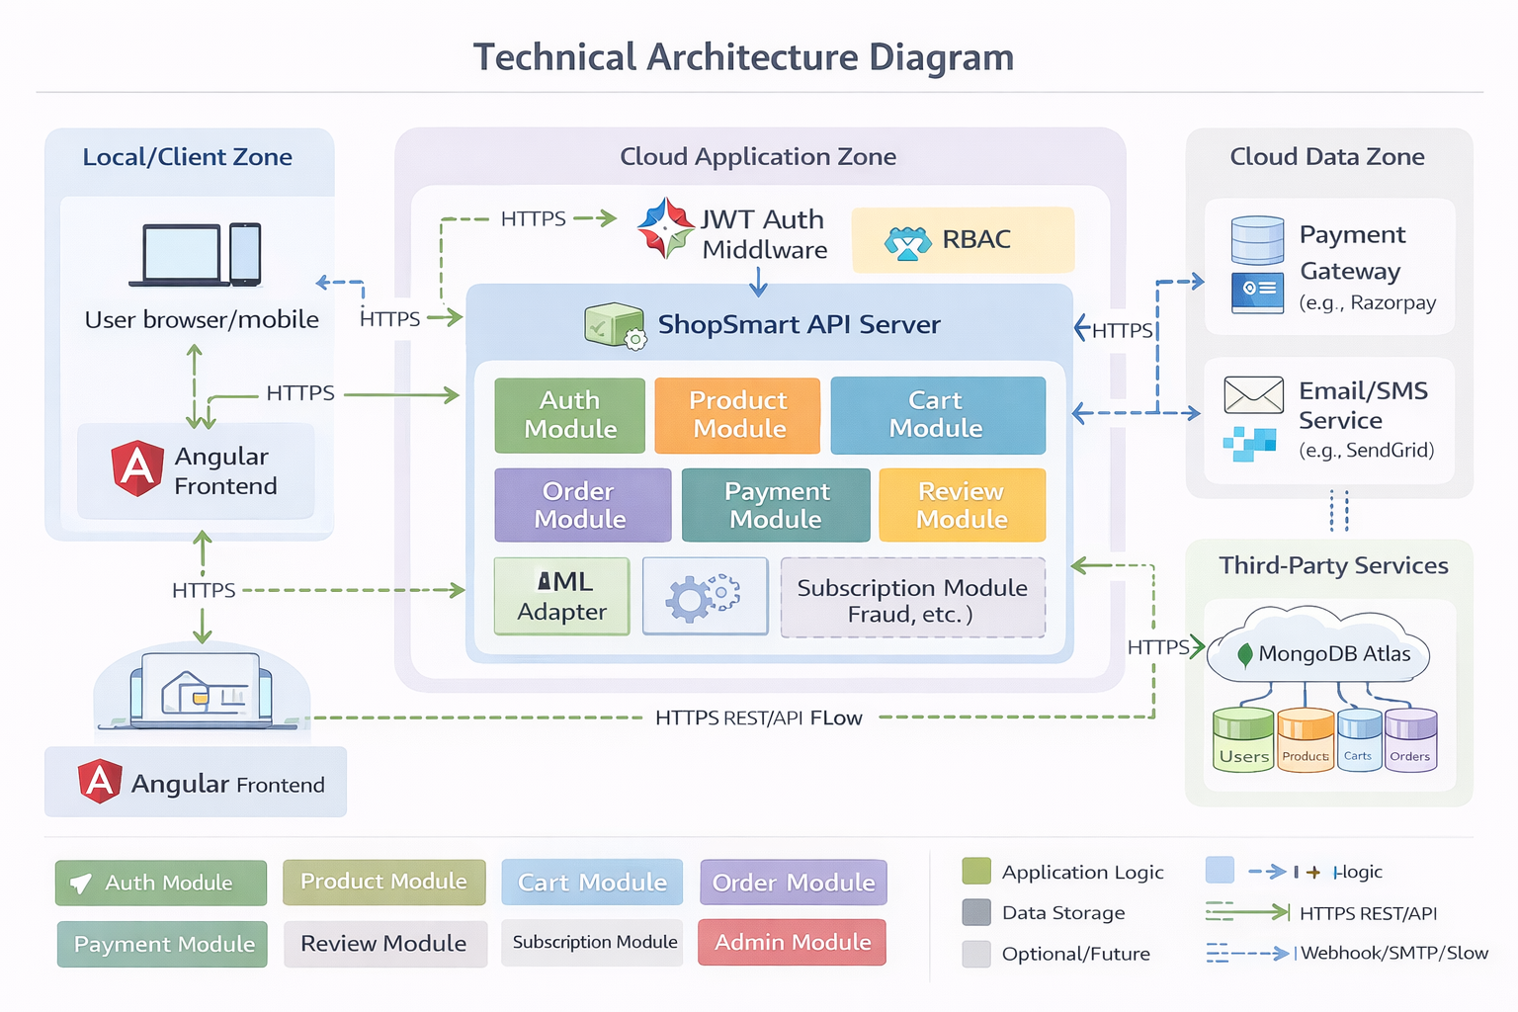
Table-1 : Components & Technologies:
S.No | Component | Description | Technology
1 | User Interface | Web interface for customers, sellers, staff, and admin dashboards | Angular, HTML5, CSS3, JavaScript, Tailwind CSS, Axios
2 | Application Logic-1 | Core business APIs: authentication, product, cart, order lifecycle, reviews | Node.js, Express.js, JavaScript, REST APIs
3 | Application Logic-2 | Access control and workflow enforcement: JWT auth, role-based access, subscription limits | JWT, Express middleware, Mongoose validation/hooks
4 | Application Logic-3 | Payments and communication orchestration: payment create/verify, email/SMS verification | Razorpay SDK/API, SendGrid API, Twilio API
5 | Database | Operational data model for users, products, carts, orders, payments, reviews, subscriptions | MongoDB (NoSQL document DB), Mongoose ODM
6 | Cloud Database | Managed cloud database for production persistence and backup | MongoDB Atlas
7 | File Storage | User/seller profile image handling and file uploads | Local filesystem (uploads/profiles), optional cloud object storage (Azure Blob/S3/IBM COS)
8 | External API-1 | Online payment order creation, signature verification, transaction status | Razorpay Payment Gateway API
9 | External API-2 | Customer communication for account verification and notifications | SendGrid Email API, Twilio SMS API
10 | Machine Learning Model | Future option for recommendations, fraud/risk scoring, demand prediction | Python ML service (scikit-learn/TensorFlow) via REST, or cloud ML endpoint
11 | Infrastructure (Server/Cloud) | Local: Angular dev server + Node/Express + local/Atlas DB. Cloud: frontend static hosting + API server + managed DB + third-party integrations | Local VM/dev machine; Cloud: Kubernetes, App Service, Docker, managed MongoDB Atlas

Table 2: Application Characteristics
S.No | Characteristics | Description | Technology
1 | Open-Source Frameworks | Full-stack open-source web architecture for rapid delivery and maintenance | Angular, Node.js, Express.js, Mongoose, Tailwind CSS
2 | Security Implementations | Token-based auth, RBAC, credential hashing, verification flows, API protection baseline | JWT, bcrypt password hashing, role-based authorization middleware, CORS policy, HTTPS, environment secrets, OTP/email verification
3 | Scalable Architecture | Modular 3-tier architecture (UI, API, DB), domain-based controllers/routes, horizontal API scaling path | Angular SPA + Express modular monolith + MongoDB Atlas; containerization-ready with Docker/Kubernetes
4 | Availability | Production-ready by deploying multiple API instances and managed DB with replication/backups | Load balancer + multi-instance Node API, MongoDB Atlas replica set, process manager/restart policy (PM2/Docker), health checks
5 | Performance | Fast API response through indexed queries, pagination, lean payloads, and static asset optimization | MongoDB indexes, pagination/filtering, efficient Mongoose queries, Angular optimized build, CDN for static assets/images, Redis cache (recommended)

